**HOSPITAL MANAGEMENT – BIG BANG PROJECT**

RAJEESH DURAI R T

BATCH-1

The main objective is to guide the development team in implementing API consumption in Angular with JWT token authentication for an admin-doctors-patient communication platform. The goal is to create a secure and user-friendly system that allows administrators to activate doctors and enables patients to register and access medical services.

There are ten tables in the hospital management database

1. Doctor Details
2. Appointment Details
3. And several tables for Authentication

**MY DB SCHEMA**:

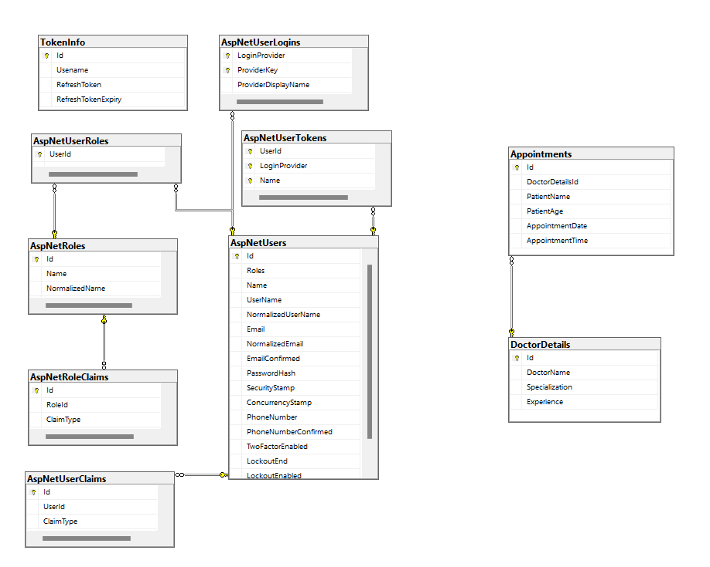

**FLOW:**

1) *User*, *Admin* and *Doctor* can only enter the project by logging in.

2) The *user* can book the appointment.

3) The *doctor* can see the appointment details of the *user* who applied

4) Admin can only give access for account registration for *doctor*

5) *Admin* can perform CRUD operations of doctor details which are displayed for the *user*